LEX PROGRAM
AIM:
To write a LEX program to read an input file, add line numbers to every line, and display the numbered contents on the standard output.
LEX PROGRAM:
%{
#include <stdio.h>
int line_no = 1;
%}
%%
^.* { printf("%d: %s\n", line_no++, yytext); }
\n ;
%%
int yywrap(void)
{
return 1;
}
int main(int argc, char *argv[])
{
if (argc != 2)
{
printf("Usage: %s input.txt\n", argv[0]);
return 1;
}
FILE *fp = fopen(argv[1], "r");
if (fp == NULL)
{
printf("Error opening file\n");
return 1;
}
yyin = fp;
yylex();
fclose(fp);
return 0;
}
Note: The rule ^.* prints each line with its line number. The newline rule consumes the line break so that it is not printed separately.
PSEUDOCODE:
BEGIN
OPEN the input file
SET line number to 1
WHILE a line is available
READ the line
PRINT line number and the line
INCREASE line number by 1
END WHILE
CLOSE the input file
END
ALGORITHM:
- Start the program.
- Check whether the input filename is provided.
- Open the input file in read mode.
- Initialize the line number to 1.
- Read each line using the LEX scanner.
- Print the line number followed by the line contents.
- Increase the line number for every line.
- Close the file and stop the program.
INPUT FILE (input.txt):
int a = 10;
int b = 20;
printf("Hello World");
HOW TO COMPILE AND RUN:
flex line_number.l
gcc lex.yy.c -o line_number -lfl
./line_number input.txt
Save the LEX code as line_number.l and save the sample contents in input.txt. Run the commands in a terminal where Flex and GCC are installed.
OUTPUT IMAGE:
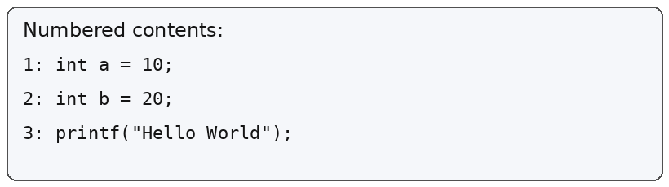
OUTPUT:
Numbered contents:
1: int a = 10;
2: int b = 20;
3: printf("Hello World");

COMPILER DESIGN: LEXICAL ANALYZER AND SYNTAX ANALYZER
Lexical Analyzer: It reads the source program character by character and groups characters into tokens such as keywords, identifiers, operators, and constants. LEX is a tool used to generate a lexical analyzer.
Syntax Analyzer: It receives tokens from the lexical analyzer and checks whether they follow the grammar rules of the programming language. It reports syntax errors when the token sequence does not match the grammar.
For this line-numbering task, the LEX program performs lexical scanning and prints each input line with a line number. A syntax analyzer is not required because the program is numbering lines rather than checking the grammar of a C program.
RESULT:
Thus, the LEX program successfully reads the input file, adds line numbers to each line, and displays the numbered contents on the standard output.

